Intro
Due to requirements in family I created a simple web for left time calculation.


Application

ideas
Set dates in the future (or past) and let the application calculate the days/hours/minutes left to that.

design goals
- add schedule to calender
- add schedule to app
- calculate all added dates
- remove schedule from app
- show information on schedule
- add a tag/info to a schedule
- multi language (EN/DE at the moment)
- Cloud integration - cloud at countdown.siningsoft.de
- Cloud integration - private cloud
- some configuration options

Implementation
function | implemented
add dates | 
calculate dates
remove dates
add date to organizer | 
cloud integration
cloud integration with web access (UID)

pictures
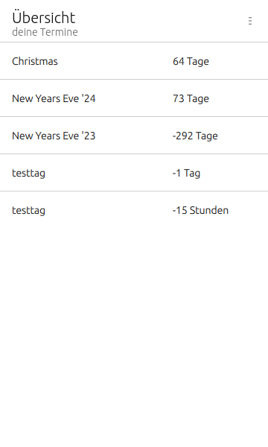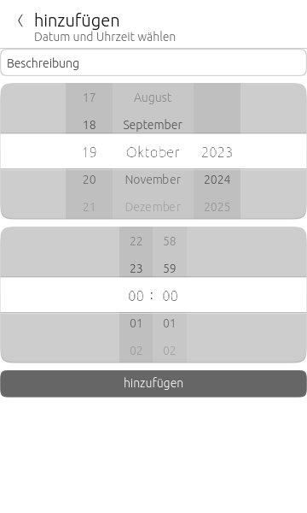

source
The sourcecode is located under svn://svn.siningsoft.de/ut-countdown. A free read access via svn will follow. If you're interested in submitting code as part of the development, a read/write access could be requested via ut@siningsoft.de

