abstract
The obdgpslogger uses a sqlite database to store its recorded data. The schema is quite undocumented. I try to do this here on my own.

schema
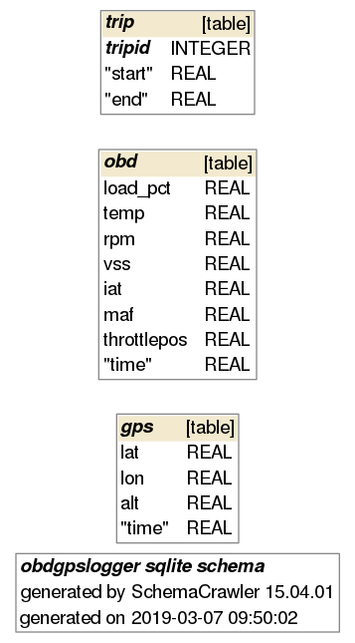
As you can see here, there are no direct conections between the tables. Its quite flat. Therfor the logi is in the application (somehow).

Tables

trip

obd
Spalte | Beschreibung | unit
load_pct | Calculated LOAD Value | %
temp | Engine Coolant Temperature | Celsius
rpm | Engine RPM | rev/min (rpm)
vss | vehicle speed sensor | km/h
iat | Intake Air Temperature | Celsius
maf | mass air flow sensor | g/s
throttlepos | Absolute Throttle Position | %
time | Tiem of dataset | unknown timestamp

gps

SQL Statements

