Introduction
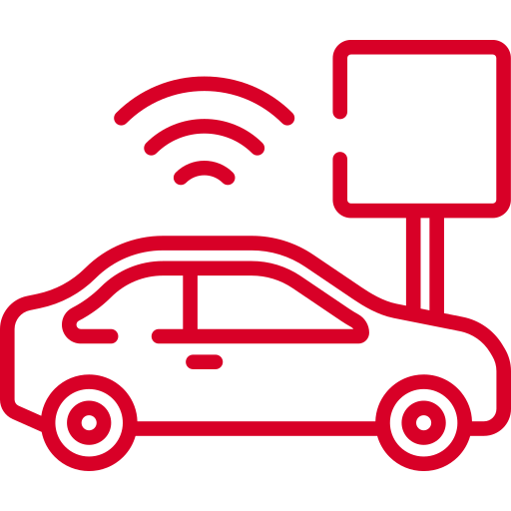
myCar is a small project to create a embedded device to connect to your cars OBD interface. It is made of some cheap parts which could be found in the hardware section.

History
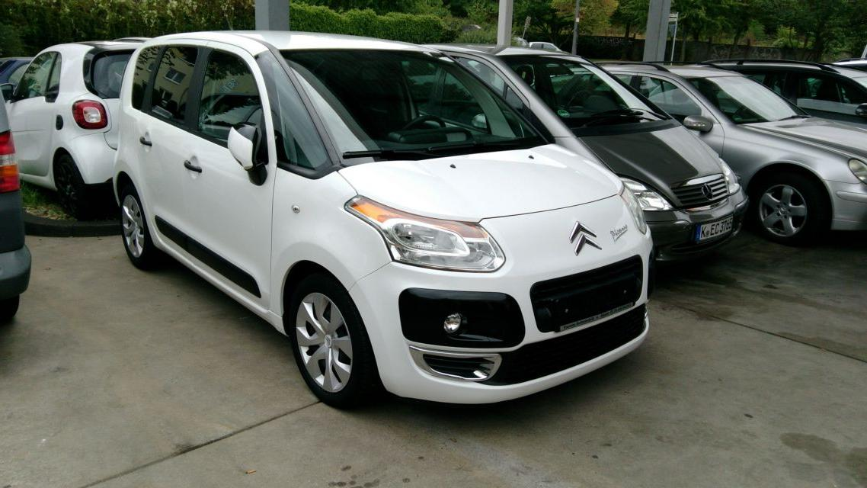
In 2018 I baught a Citroen C3 Picasso from 2010 with about 85000 km as a intermediate car between my already sold one and the delivery of the new one. After some kilometers of driving I encountered some errors regarding the VTI (Vanos) system and I tried to design some analysis tool around this problem to check the situation when and how it occurs.
To check the ECU error codes with my Linux devices I've found a real cool tool called obdgpslogger. It seemed to me that this is the right tool to have long time analysis of the engine behaviour to debug defective parts.
Allthough its clear to me that there are APPs around I've got a problem using my SailfishOS for such stuff, because the only available tool OBDFish is not working properly with my ELM327 Bluetooth dongle.
So I started to use obdgpslogger. But its quite uncomfortable to me to use a laptop for data aquisition. So my idea is to have a small embedded device like a OrangePI Zero (I've had one in spare) and enhance it for obdgpslogger.
To create some better user experience a frontend is needed and some automation so that the embedded device is automagically capturing data once it is powered up.
Et voilat …. myCar was born.

News
2019-05-15 Decided to switch from obdgpslogger to pyobd and some python gpsd interface. To achieve a fully contained environment, the flask application server will be the core application to handle the OBD connections, the gps updates and a sqlite database which holds the data.

Wiki Overview
The following pages are available for your documentaiton.
- Hardware
  - Overview
  - Building instructions
  - buylist
  - Armbian on OrangePi Zero notes
- Software
  - Software components
  - Design
    - Homescreen
    - Live Data
    - Recordings
    - Configuration
    - Bluetooth Controller
    - Bluetooth Devices
    - GPS
    - WiFi
    - System
  - Database
  - Source
  - Paths
  - manual installation side notes
  - manual usage instruction
  - Licenses
- Usage instructions
  - connecting to myCar unit
  - connecting to your car
  - start recording
  - getting data
- Additional
  - Artwork
  - Screenshots

Contact
For any information you can reach me via mail mycar@siningsoft.de

Visitors to this page in total

